**Issues found:**

**Processes – Role: HR**

1. User is redirecting to pre-Offer stage on clicking on save button in client stage.

Steps to produce:

* Click on edit button.
* Fill all the mandatory details.
* Click on save button.

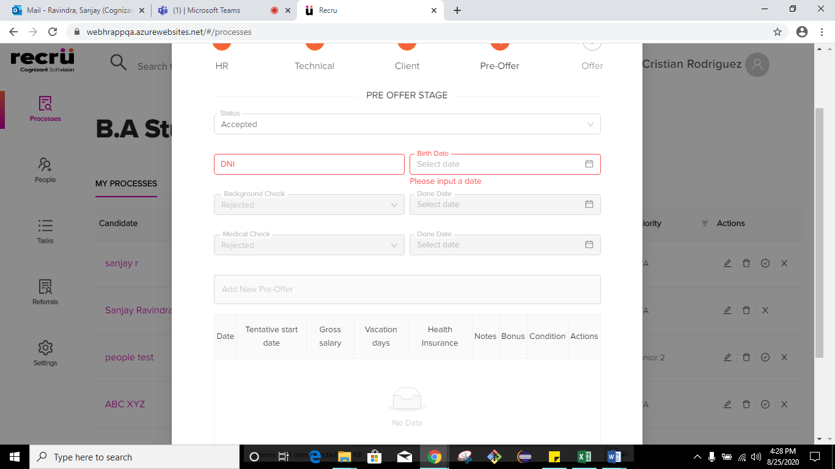

1. Same option is present multiple times in Reason dropdown.

Steps to produce:

* 1. Click on new candidate button.
  2. Scroll down and select the status as Rejected.
  3. Click on Reason dropdown.
  4. Observe **High Salary Requirements** is repeated twice.

